Test Case 1 : Adding Movie

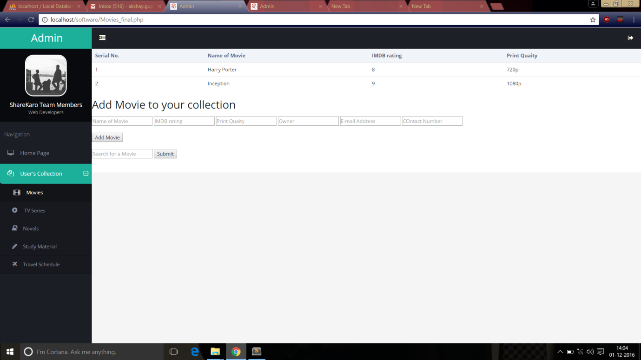

Positive : If all the fields are according to the variable data type, it will be inserted successfully.

Negative : When suppose a name is entered in IMDB rating, the entire row entry wont be successful in the MySQL Database of the user’s collection.

Test Case 2 : Adding TV Series

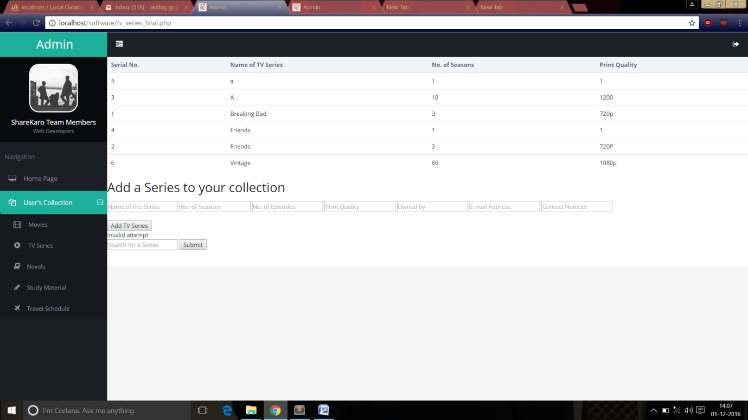

Positive : If all the fields are according to the variable data type, it will be inserted successfully.

Negative : When suppose a string is entered in place of contact number, the entire row entry will not be successful in the MySQL Database of the user’s collection.

Test Case 3 : Redundant Movies/TV Series



Redundant Movies/TV Series/Novels are being allowed in the database as people can approach different individuals for all sorts of collectables. This flaw in a way connects more people.